Directions for Installing FileZilla

Click on “I Agree” for this License Agreement
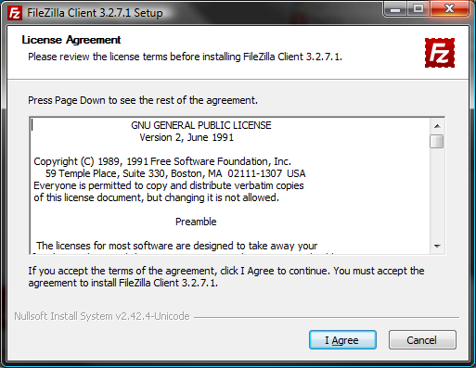

Make the selection as to who will be using this computer and then select “Next”
Your version will say 3.5.3
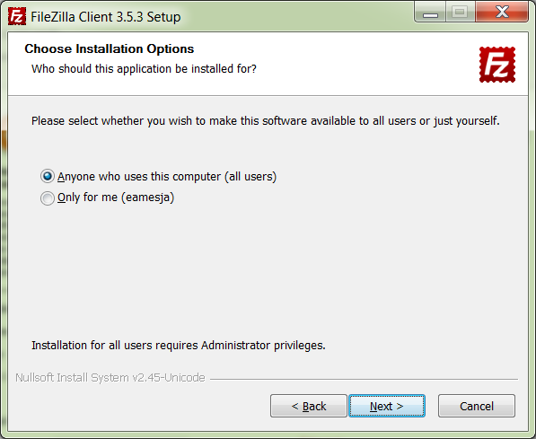
Select the components you want installed; please note the recommendations.
Click “Next” when finished with the selections.
Your version will say 3.5.3
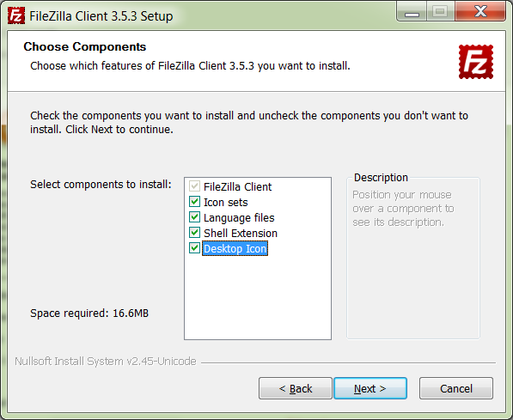

Using the “Browse” Button, select the Destination Folder.
Click “Next” when finished.
Your version will say 3.5.3
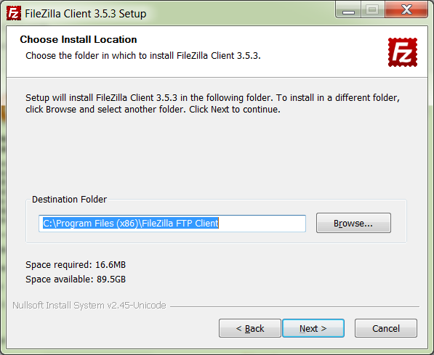
Choose your Start Menu Folder; Recommendation is displayed below.
Click “Install” when selection has been made.
Your version will say 3.5.3
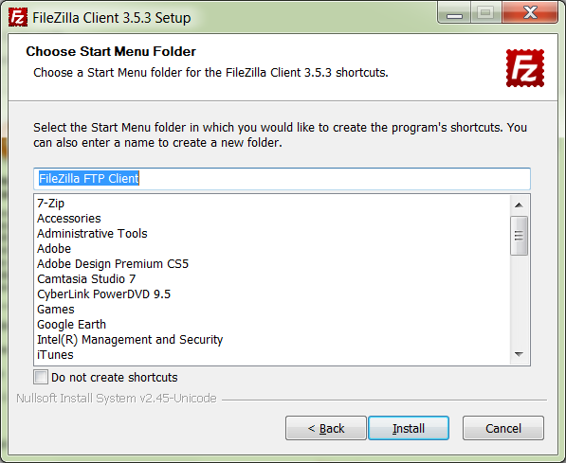
When the Installation has been processed, you need to click on “Finish” to close SetUp.
You can check the “Start FileZilla” now button to open FileZilla up.
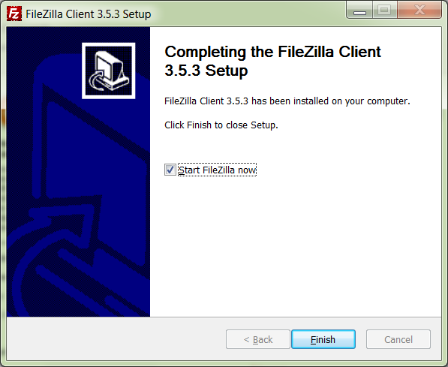

You are now ready to use FileZilla. Please refer to the “FileZillaHelpDocument.doc”.

